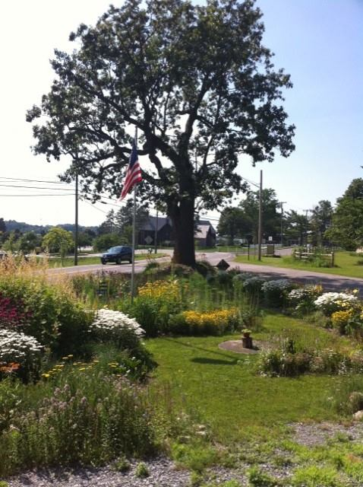 Design the 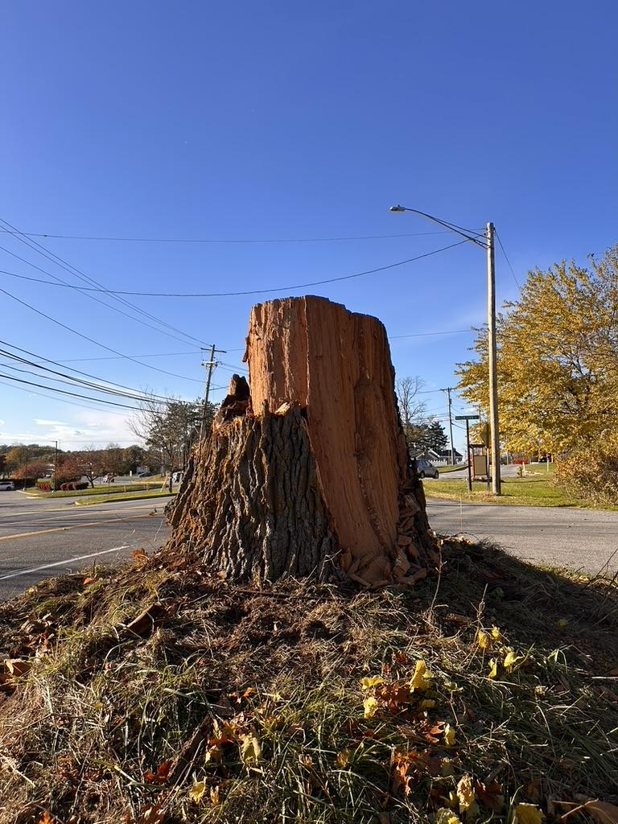
Historic Valentown Oak Little Free Library

As many of you know, our majestic Valentown Oak (ca. 1735–2025) came down on November 3, 2025. Our landscape will never be the same, but we can honor this remarkable tree by continuing its life as a Little Free Library. Historic Valentown is inviting the public to submit designs for a library built with the trunk of this amazing oak. We are looking for a structure that sparks curiosity, withstands the elements, and brings our community together through the love of reading.
The finished library must remain within the existing triangle and should preferably be made with long-lasting natural, metal, or recycled materials. Participants are encouraged to visit, measure, and photograph the trunk before submitting a design.
Designs should honor the oak’s history while creating a welcoming, practical place for neighbors to exchange books.

Core Design Requirements
- Weatherproofing: Include a sloped roof with at least a 2-inch overhang on all sides to help keep rain off the door and trunk, along with weather stripping around the door.
- Visibility: Use a clear front panel so visitors can see the books inside. Plexiglass or polycarbonate is preferred over glass for safety.
- Accessibility: Provide an easy-to-grab handle and a mounting height accessible to both adults and children, usually 36" to 42" from the ground.
- Airflow: Add small vents at the bottom or sides to reduce condensation and help protect the books from mold.
- Capacity: Design the interior to comfortably hold 20–30 standard-sized books.
- Maximum exterior dimensions: 24" W x 24" D x 30" H.
- Minimum interior depth: 10" so books do not prevent the door from closing.

Submission Requirements
Please submit one PDF that includes the following:
- Concept statement: A brief paragraph explaining your design inspiration.
- Visuals: A 3D rendering or detailed hand sketch showing front and side views.
- Basic plan: A rough schematic showing major dimensions.
- Color palette: Suggested paint or stain colors.
- Contact information: Your name, phone number, and email address.

Official Contest Rules
- Eligibility: Open to all: students, Scout troops, community groups, artists, builders, and design enthusiasts. Minors should include parent or guardian contact information.
- Ownership and use: By submitting a design, the designer grants Historic Valentown Museum permission to construct, adapt, and display the design as needed for safety, durability, budget, and site conditions. Credit will be given to the original designer on a permanent plaque.
- Judging criteria:
  - 30% Aesthetics: Does the design look inviting, unique, and fitting for the historic oak?
  - 40% Functionality: Will it keep books dry, visible, and easy to access?
  - 30% Buildability: Can it be reasonably constructed with durable materials and standard tools?
  - Prize: The winning designer will receive a free family membership to the museum and recognition on a permanent plaque naming the designer and builders.

Submission deadline: August 30, 2026. Winner announcement: September 20, 2026.
Submit designs to: collections@historicvalentownmuseum.org
Scout troops and Eagle Scout candidates: We would love to partner with a troop or candidate to help design and build a small protective fence and/or construct the prize-winning library.
Help us turn the Valentown Oak into a lasting community treasure. Submit your design and be part of its next chapter.

